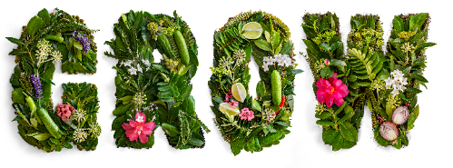

Grow Ō Tautahi Media Release – 2 December 2019

Everyone’s invited to celebrate community gardens at Grow Ō Tautahi

Visitors to Grow Ō Tautahi Christchurch Garden Festival will be able to explore and play in an inclusive exhibition garden designed by Canterbury’s 32 community gardens.

The Canterbury Community Gardens’ Association (CCGA) is bringing together all of the region’s community gardeners to create “We Too” – an interactive garden where visitors will be able to sit on living furniture, enjoy the peace of a lush garden space, play amongst living sculptures and post photos of their adventures.

Grow Ō Tautahi Festival Director Sandi MacRae says the community gardens exhibition will be a special highlight of the event.

“Grow Ō Tautahi is a homegrown festival that draws on our region’s love of gardens, creativity, innovation and design. We are absolutely focused on our local community so it’s really exciting to have all the region’s community gardens represented in one very special exhibition.

“When I first heard of the ‘We Too’ garden concept, I knew people would fall in love with the idea. You’ll be able to come along, take photos of yourself on the living furniture and look through viewfinders which will transport you to each of the individual community gardens dotted around the region.

“What better way to celebrate the concept of the community coming together to work in a garden and create a special place that everyone can enjoy,” Sandi says.

CCGA Chair Catherine O’Neil says community gardening is all about inclusiveness. “Whether you’re eight or 80, a community garden is a place you can wander into and find a place to that makes you feel at home. You might want to pick up a spade and get digging, or perhaps you’d rather just sit and enjoy the beautiful surroundings, whatever your pleasure, community gardens are there for everyone.

“The CCGA is so excited to be able to bring all of Canterbury’s 32 community gardens together to create a special garden that the people of Christchurch can take delight in at Grow Ō Tautahi. We’re working hard right now to grow the plants and develop a design that will be sustainable, inclusive, collaborative and fun – all the things community gardens represent,” she says.

For three days in March next year, the Christchurch Botanic Gardens will play host to the most innovative, exciting new garden festival on the horticultural calendar – Grow Ō Tautahi. A homegrown festival design specifically for the Garden City, Grow Ō Tautahi is a creative and environmentally aware event that draws on ideas from across the community.

Grow Ō Tautahi is FREE for the public to attend and will include exhibition gardens, floral displays, the community garden, schools gardens, workshops and panel discussions on key environmental issues, a celebrity chef garden kitchen demonstrations, entertainment, food and plenty of fun for everyone.

Grow Ō Tautahi, 20-22 March 2020
For more information contact: Amanda Healy, pr@growotautahi.org.nz +64 21 2388 938

